User manual for 3D scanning patients

How to perform a 3D scan for ordering bolus

Contents

About this manual 2

Start the app 2

Settings 2

Perform the scanning 3

Save the scanning 6

Upload the file to a computer 7

About this manual  
This user manual is for healthcare professionals who want to 3D scan a patient’s ear to order a bolus for radiation treatment. This manual will explain how to use the 3D camera, scan the patient, and order the bolus.

It is recommended to follow the manual to get the best results.

# Start the app

1. Take the iPad and camera out of the charger
2. Make sure the camera is mounted on the iPad as seen in the picture below

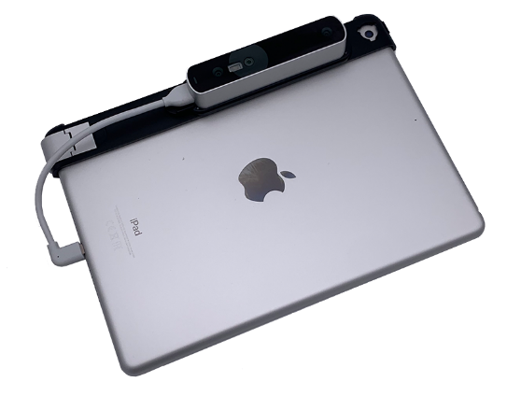

1. Plug the camera into the iPad using the wire

|  |  |
| --- | --- |
| 1. Open the app Structure scanner SDK |  |

# Settings

1. Press the Icon

   Description automatically generatedin the top left corner
2. Check that the settings are the same as the pictures below

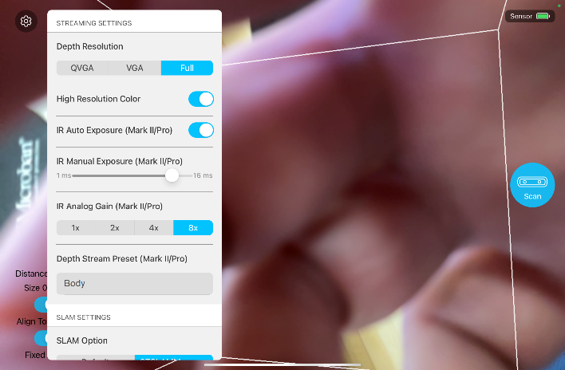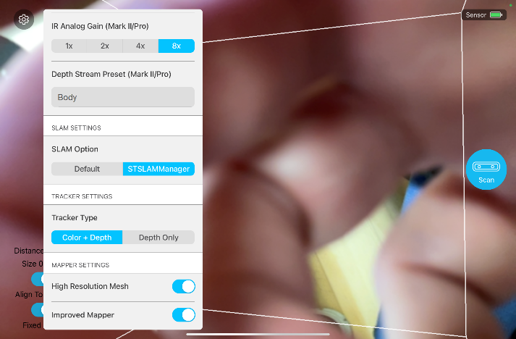

|  |  |
| --- | --- |
| **Name** | **Setting** |
| Depth resolution | Full |
| High resolution color | On |
| IR auto exposure | On |
| IR manual exposure | 16 ms |
| IR analog gain | 8x |
| Depth stream preset | Body |
| SLAM option | STSLAMManager |
| Tracker type | Color + depth |
| High resolution mesh | On |
| Improved mapper | On |

# Perform the scanning

1. Ask the patient to remove all visual jewelry from the neck and up, glasses and hearing aids.
2. Place the patient on a chair in the middle of the room - make sure there is space to move around the patient.

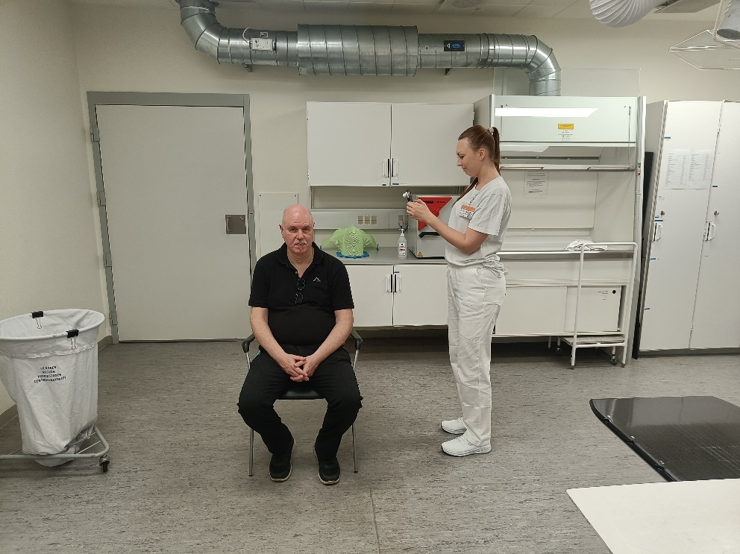

1. There is a white cube on the screen here it is important to set the distance and size in the bottom left corner.
   1. Distance is set by using two fingers and moving them forward or backwards on the screen. The distance should be set to the lowest.
   2. Size is set by using two fingers. When moving the fingers apart the size is expanded and pinching your fingers apart decreases the size. Set the size to 40-50 cm.
2. Stand and point the camera at the patient’s ear that needs to be scanned.
3. Move further and closer until the area you need to scan turns yellow.
   1. If the area appears red you must move further away
   2. If the area has normal colors move closer
   3. When the area is yellow you are ready to scan

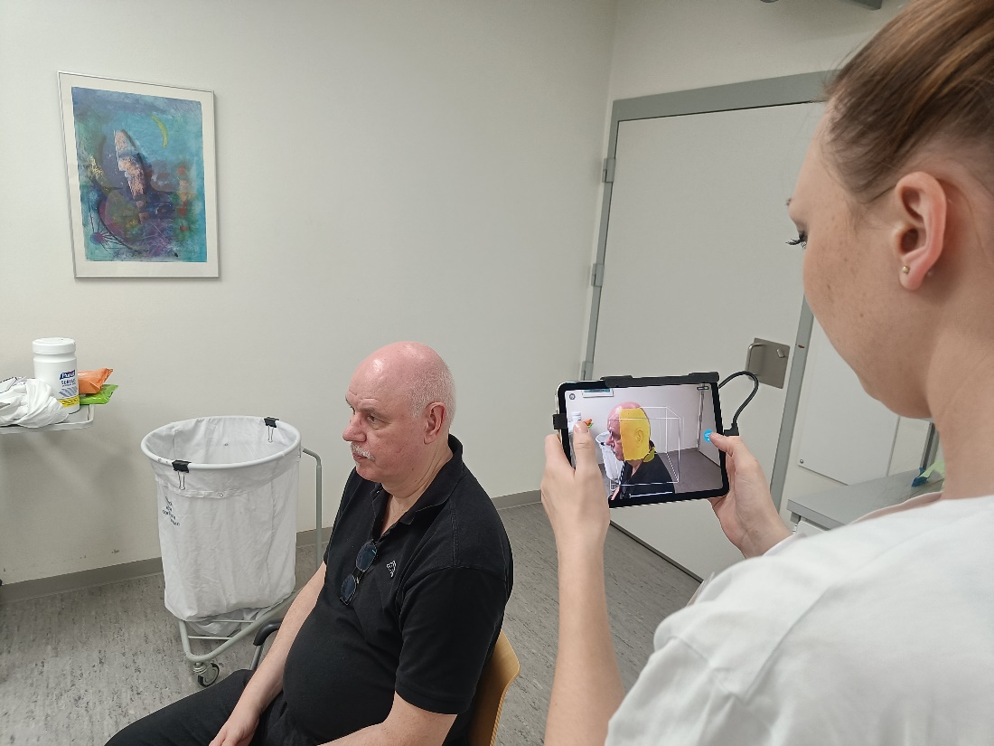

The patient will appear yellow when ready for scanning.

1. Press scan on the right side of the iPad Graphical user interface

   Description automatically generated with medium confidence
2. Pressing scan makes the model turn grey. The grey area is the model. Anything not grey needs more scanning.

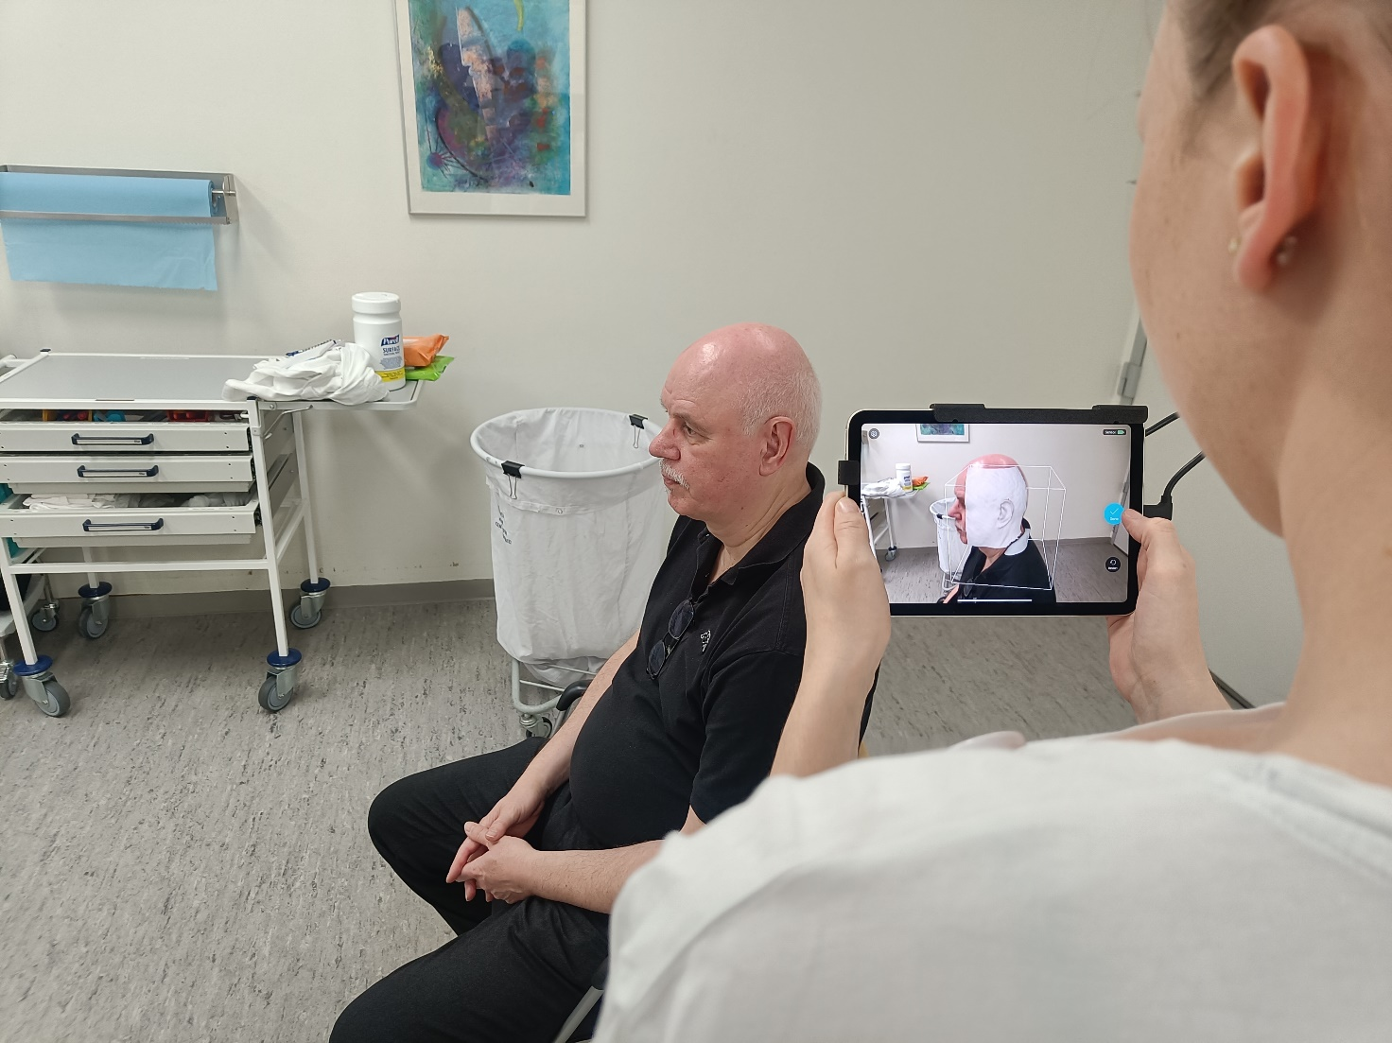

1. SLOWLY move around the patient. Make sure to scan both behind the ear, the top and the bottom.

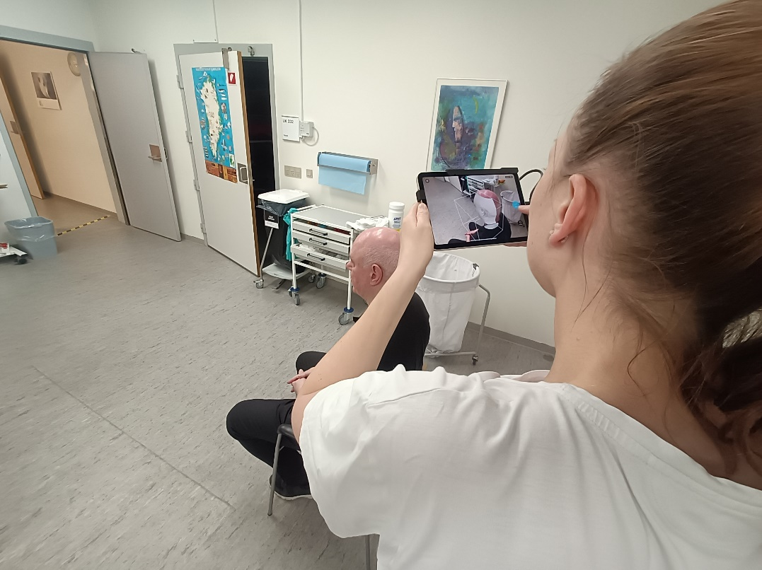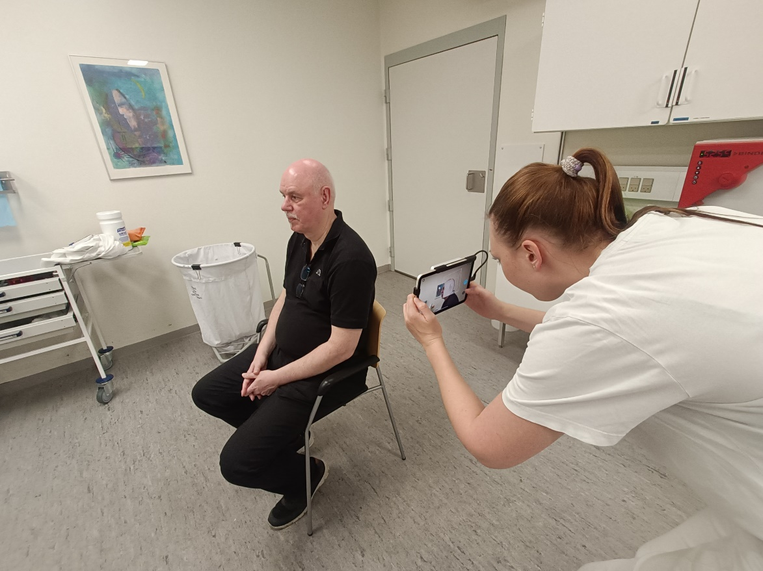

1. It is important to move slowly and sometimes even stand still to give the camera time to make the model.
2. While scanning the model can appear red. This means you moved too close and have to move further away to proceed scanning.

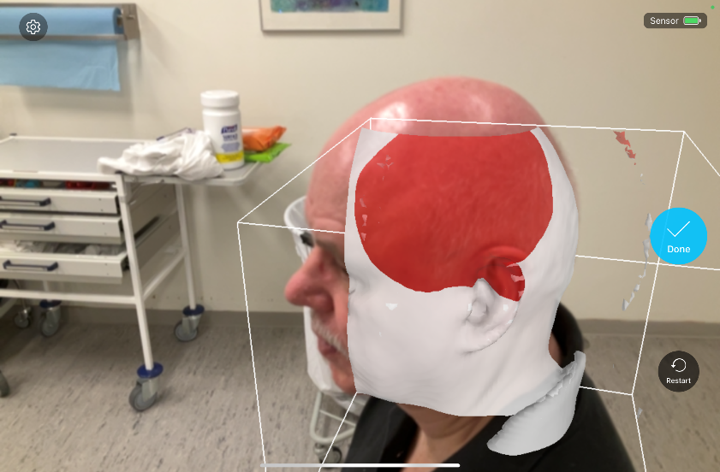

1. While scanning a blue pop-up can appear at the bottom of the screen. When this appears stand still and wait. When the pop-up disappears continue scanning.

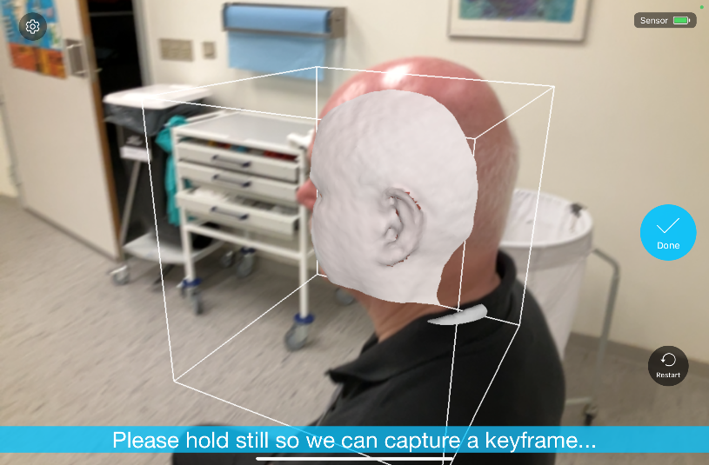

1. When done scanning the patient press done on the right side Icon

   Description automatically generated with low confidence.

# Save the scanning.

1. When scanning is done you need to save the file. 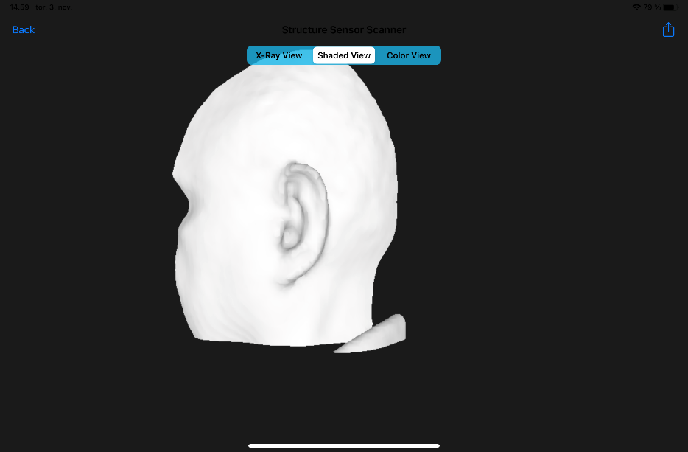
2. shaded view
3. Click the icon
4. Make sure you are in “Shaded view.”
5. Click the  icon in the top left corner.

1. Click on the file manager.
2. Click on “file manager.”
3. When this window pops up the file is saved.

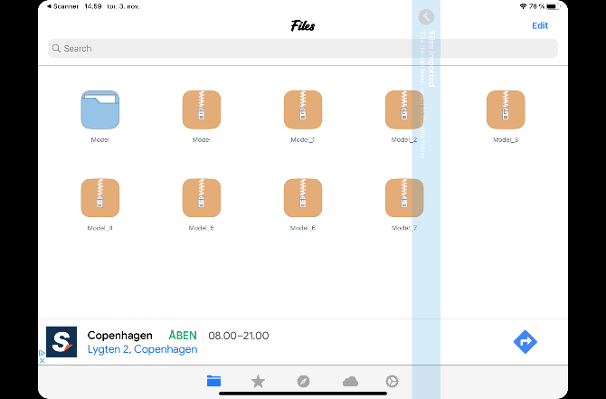

# Upload the file to a computer.

1. Remove the wire connecting the camera to the iPad and wire the iPad to the computer instead.
2. Open ITunes on the computer
3. Press TWICE on the iPad icon.

1. Press “fildeling” and afterwards “File manager”

1. Select the model/models you need to save by clicking them. You can check the **date** and **time** if you are unsure of which model you need.
2. After selecting the model/models scroll down and click “gem”

1. The pathfinder will appear. Select the folder “Bolus” on the R drive. ”R:\Fælles mappe - 3D print\Bolus”. Right click and create a new folder.

1. **Name the folder the CPR number of the patient.**
2. Select the new folder and press “Vælg mappe”

1. Create a new folder having the ID (first time 01, second time 02 etc).
2. Open the pathfinder afterward and go to the folder where you just saved the model.

1. Name the file the name of the patient and the body part scanned.

1. Remember to upload pictures where the tumor is marked to the patient folder as well.

# Place order for bolus

1. Go to “R:\Fælles mappe - 3D print\Bolus” and open “Bolus bestillingsseddel”
2. Fill in the information and send it to [bolus.center-for-hr@regionh.dk](mailto:bolus.center-for-hr@regionh.dk)